DIY Guide Groupwise to Outlook for Linux

This DIY guide will help you go through the migration of your online mailbox, frequent contacts, and calendar from GroupWise into your Linux mail client. This will be done by using Citrix to export from GroupWise and import into Outlook in a Windows environment, and then just adding your Exchange account into your Linux mail client – Evolution Mail as example in this document – to sync everything in.

Using other clients such as Thunderbird may require you to download a non-free plugin (such as OWL) to connect to Exchange.

Please read each section of this guide.

NB:
There are preparation steps to be taken by IT the day before on the back end – so please send your intent to migrate (and NWU number) to Louw.Venter@nwu.ac.za the day before.
The following morning before 9:00 your emails will be directed to the Exchange account, and you can proceed with the migration steps below.

Step 1 – Working on Citrix

Citrix gives you access to a virtualized Windows Desktop which you can access through a browser.

- Open https://apps.nwu.ac.za/Citrix/NWU_PortalWeb/ in a browser and log in with your NWU credentials
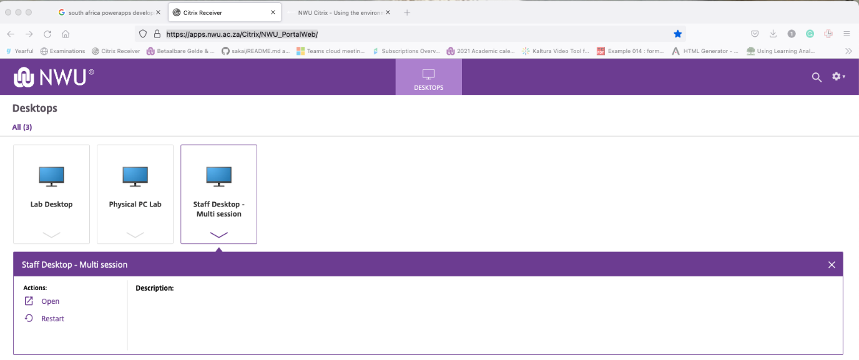

- Open the Staff Desktop – Multi session under the Desktops heading by clicking on the icon, or clicking Open under the slide-down menu.

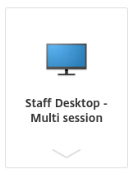

If you run into issues with the virtual Desktop, or want more info on how to use it please see the Citrix Getting Started guide at https://nextcloud.nwu.ac.za/index.php/apps/onlyoffice/s/W7XQciJzXomNSxd

- Once the virtual Desktop has loaded, open GroupWise and take the following steps:

3.1 Create a ‘Forwarded Exchange’ folder in GroupWise:
- Select your GroupWise Home folder, right click and select New Folder;
- Rename the folder to Forwarded Exchange.
This is where all mail will go after being forwarded to outlook.

3.2 Setup a forwarding rule
In GroupWise select Tools, Rules, Add, New
Enter the Rule name and tick the New Item and Item types displayed as follows:
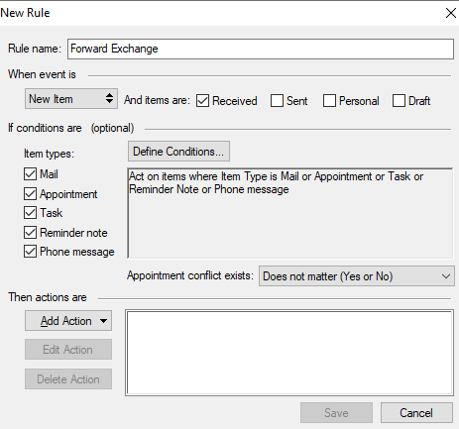

Click Add Action
Select Forward as Attachment…
In the forward dialog box use the email address nwunumber@ms.nwu.ac.za in the To field.

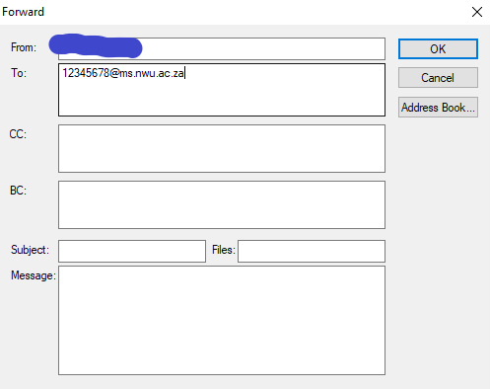

Click OK
Click Add Action
Select Move to Folder…
Select Forwarded Exchange

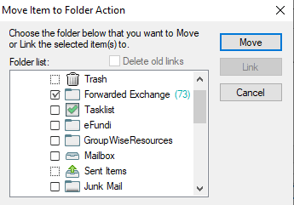

Select Move

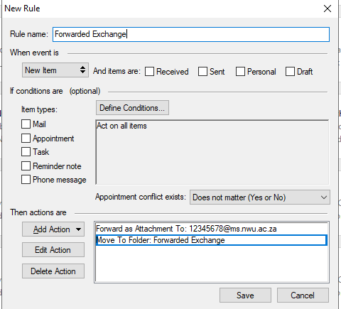

Click Save
Make sure the “Forwarded Exchange” Rule is the first on your Rule list.

NB: Make sure you use forward as attachment forwarding rule.
From this point ALL new mail will now flow to Exchange and Outlook (Evolution) will be used as the email Client.

3.3 Optional (deletions will have to be done manually in GW if not set up like below):
Mail will build up in the forwarded folder. If a user receives a lot of mail this might end up filling up the mailbox and mail will not be forwarded any more. Follow the next steps to do an automatic clean-up in GroupWise. In Groupwise, select Tools, Options, Environment, Cleanup. The suggested settings are as follow:

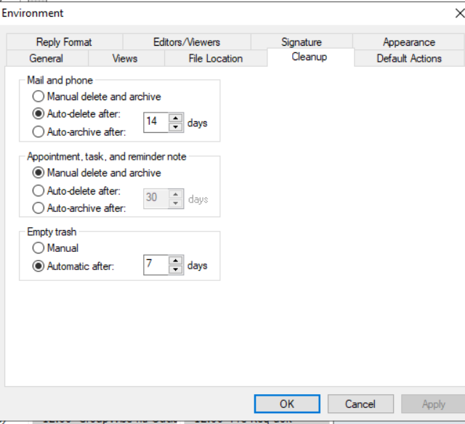
GroupWise will Auto clean up the mail after 14 days and it will remain in the trash for 7 days in case if a user wants to recover a mail.
Please note: As GroupWise will still be used as the main Calendar software, don’t setup the Appointment, task, and reminder note section.
IMPORTANT: Only the calendaring function will be used in GroupWise at this stage.
- Search for “Shoviv” in the Start menu and run Shoviv GroupWise to Outlook. This is the utility which will be used to export your mail to a single PST file for import into Outlook.

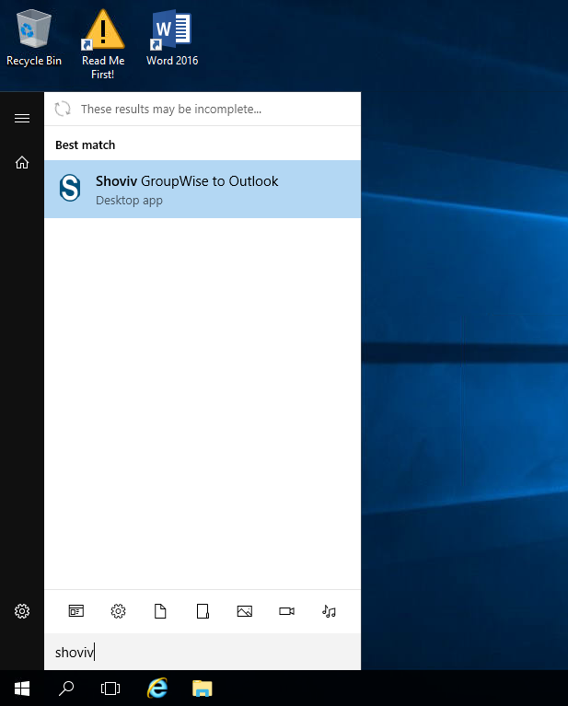

- Follow the steps from page 2 in the 03_HowToConvert.docx procedure document to export (from GroupWise) and import (to Outlook) for your Online mail, Frequent Contacts and Calendar. Please see the important notes below before doing this.

You can export your archive (HowToConvert page 6) but do not attach it to Outlook in Citrix as per the HowToConvert guide - rather place it on NextCloud or download it via the built-in Citrix controls. Adding your archive into Linux is discussed in Step 3 of this guide (p16)

Important - please note:
- When exporting from GroupWise in Citrix, do not use the Desktop, Documents or Downloads folder as an export destination. Rather use c:\users\YourNWUno\ and create the export folders there. Citrix does folder redirection to a file server with size quotas on some folders and placing the exports in that folder may result in a failed export (being rejected by the file server).

- Although the regular migration process has Office 365 as prerequisite, the Staff Desktop still has Office 2016 installed. This version has however been tested to work with Exchange. If you are also planning on using Outlook on your Windows PC it is recommended that you load Office 365 to ensure compatibility.

- During account setup in Outlook on Citrix you will be prompted to log in – your NWUno@adt.nwu.ac.za will automatically be filled into the prompt for the ADT domain – this is because you are working on Citrix and logged in with that account.
Click on More choices and select to Use a different account instead and specify your @nwu.ac.za format email to log into with – the nwu.ac.za domain will then be displayed.

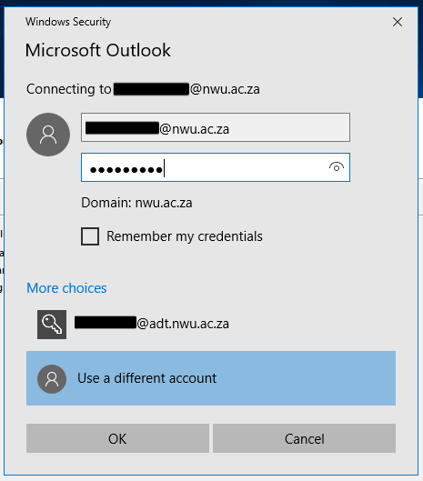

- When promoted whether you want to use auto discovery of the email server settings, choose to Allow it

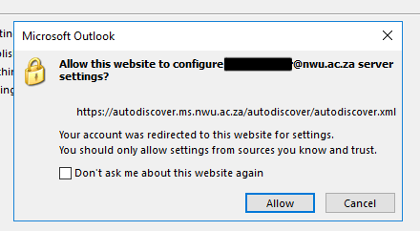

After following the separate HowToConvert document you should now have your emails set up in Outlook, and an optional PST archive file.

Step 2 – Add account to Evolution Mail (after export/import in Citrix)

Before adding your Exchange account to Evolution, you may need to install an additional package evolution-ews from your repository to connect to Exchange Web Services.

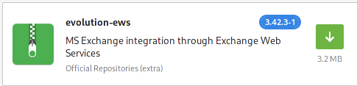

In Evolution add a new Mail account by following Edit –> Accounts and selecting to add Mail Account in the dropdown menu.

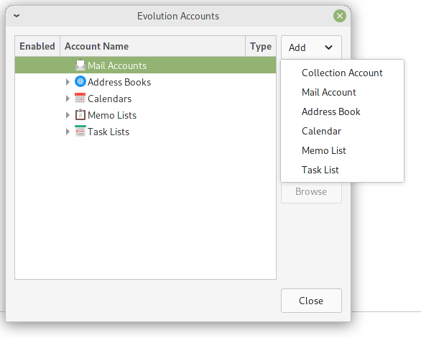
Click Next to move to the Identity screen

Enter your Full Name and Email Address

Click Next to continue to Receiving Email

Select Exchange Web Services option in the Server Type dropdown

- Enter your email address (in name.surname@nwu.ac.za format) in the Username field (only use your nwuno@nwu.ac.za format email if you have not personalized your email address)
- Enter https://mail.ms.nwu.ac.za in the Host URL field – click on Fetch URL and wait
- Enter your password in the resulting Authentication Request popup – the OAB URL should auto populate. - The Host URL may change depending on where your mailbox is located.

Very important:
Depending on whether your Exchange mailbox is on-premises or has already been moved to the cloud the authentication method will have to change accordingly. If you are just moving from GroupWise now, your mailbox will still be on-premises.

Mailbox still on-premises:

Under Authentication change the type to NTLM and leave the rest of the settings default.
Click Next to proceed

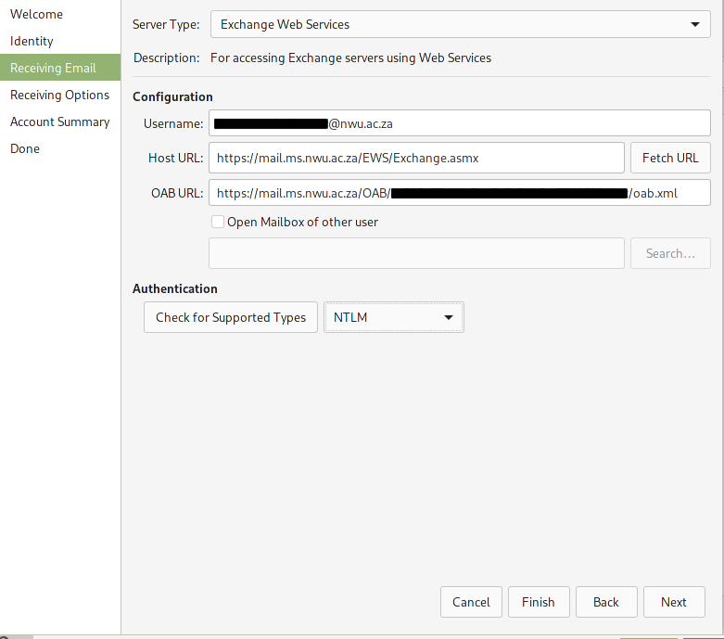

Mailbox already moved to the cloud:
Click Fetch URL to update settings.
Make sure the host URL is https:// outlook.office365.com/EWS/Exchange.asmx
Under Authentication change the type to OAuth2 (Office 365). If the Application ID does not populate, please enter 20460e5d-ce91-49af-a3a5-70b6be7486d1 as Application ID in that field and leave Tenant ID as common.

Click Next to proceed

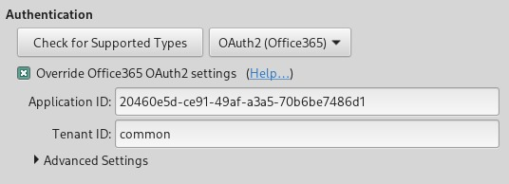
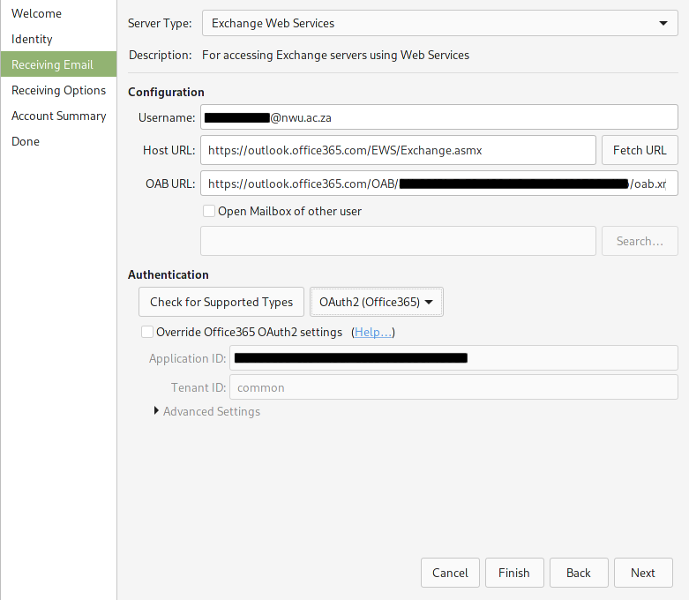

Customize Receiving Options to your preferences, and click Next

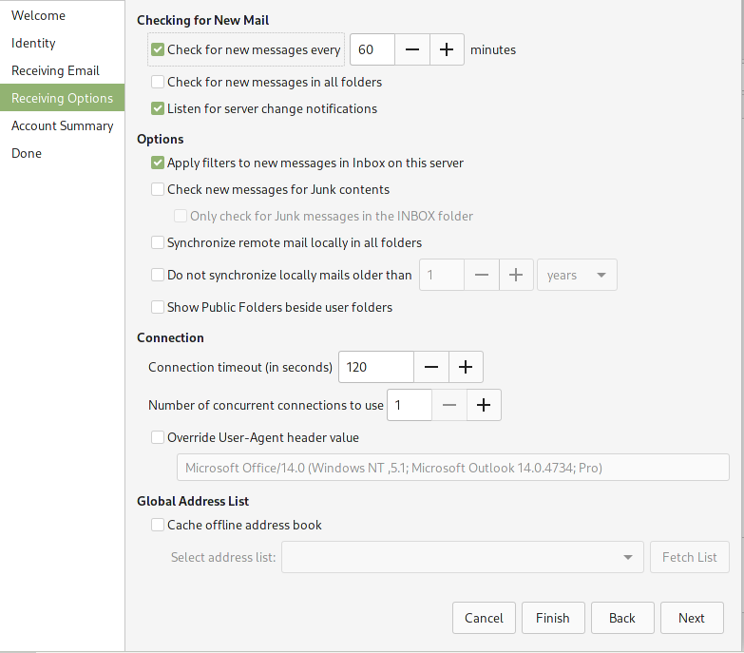

Give the account a name of your choice under Account Summary and click Next to continue, and click Apply to add the account

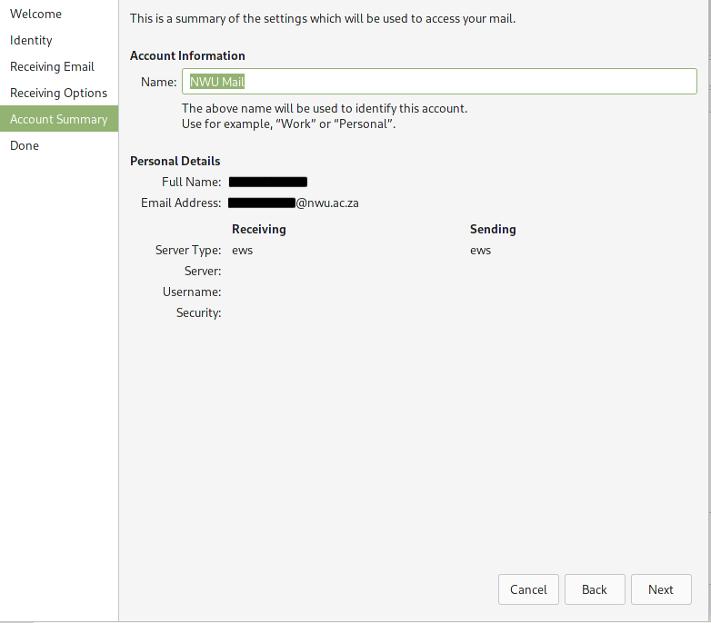

A login screen may appear. Select Work or School account

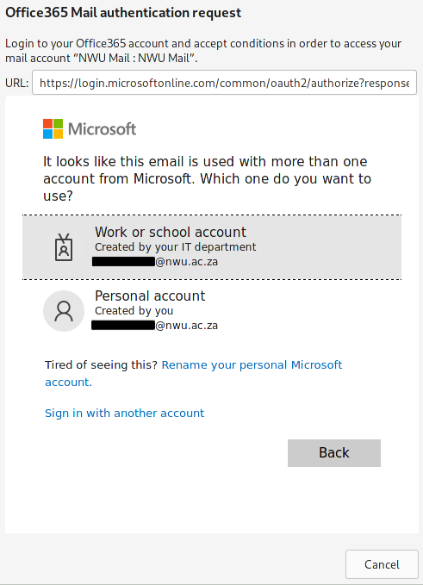

On the next screen select Active Directory

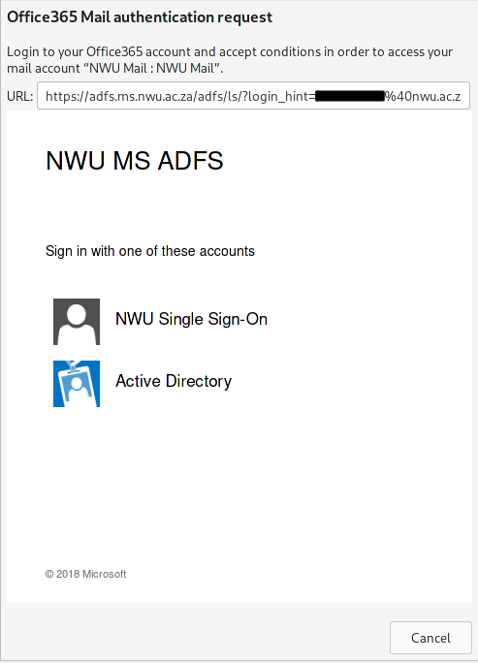

On the resulting login screen enter your password and log in.

After logging in and having your account added you will be presented with an Account Summary.
You can choose to remove the US holidays calendar entries in your Calendar.

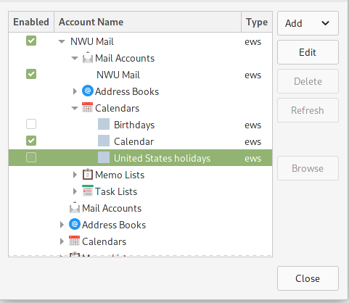

Note on Meetings
Make sure your select the correct Calendar when scheduling a meeting otherwise the meeting won’t create in your online calendar and the ‘Busy Search’ (Scheduling) won’t work for attendees.
This can be done each time you schedule a meeting
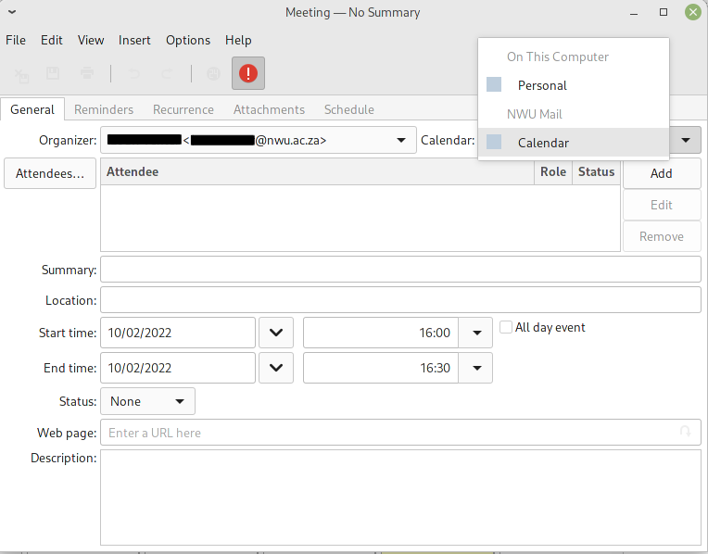

Or, perhaps easier, disable all other calendars in Account Settings so only your online calendar is the only option when scheduling a meeting.

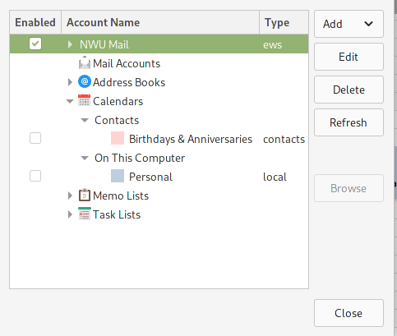

Step 3 - Adding the *.pst archive

Transfer the archive *.pst file from NextCloud or from Citrix to your local device.

In Evolution go to File -> Import and click Next on the resulting Evolution Import Assistant which opens up.

On the Importer Type screen select Import a single file and click Next

On the Select Information to Import screen click to browse for the archive *.pst file by clicking the box next to Filename. The File type should be Outlook personal folders (.pst) – if not change it to that effect and click Next.

On the Import Location screen, you can select to where the Archive should be imported. In the example below I chose my Archive folder in my online mailbox structure (NWU Mail).

NB
If you choose a folder in your online mailbox (like the in the example) the archive will be imported into your online mailbox (synced to your Exchange mailbox online).
If you do not want to do this, or don’t have enough space in your mailbox choose a destination in the On This Computer structure which will be stored locally. You can refer to this folder if you need something from your archive in the future.

